Step 1:  
Connect mumbai-testnet to the wallet  
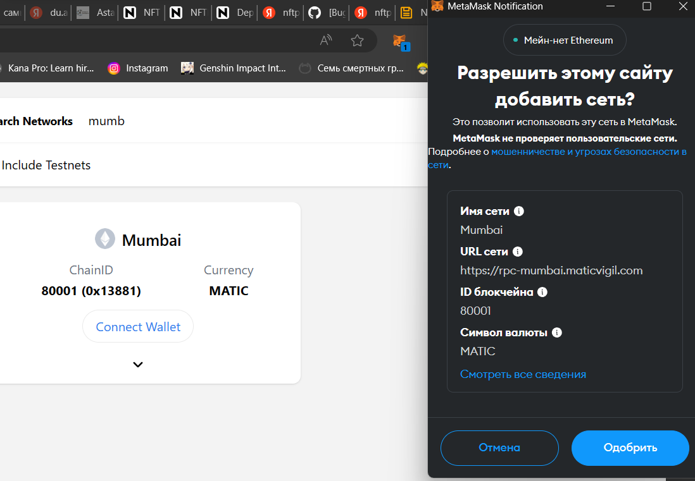

Step 2:

Signup for free filebase account  
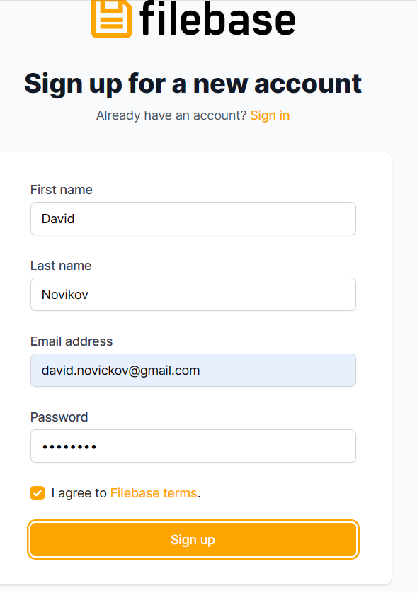

Step 3:  
Setting up filebase bucket  
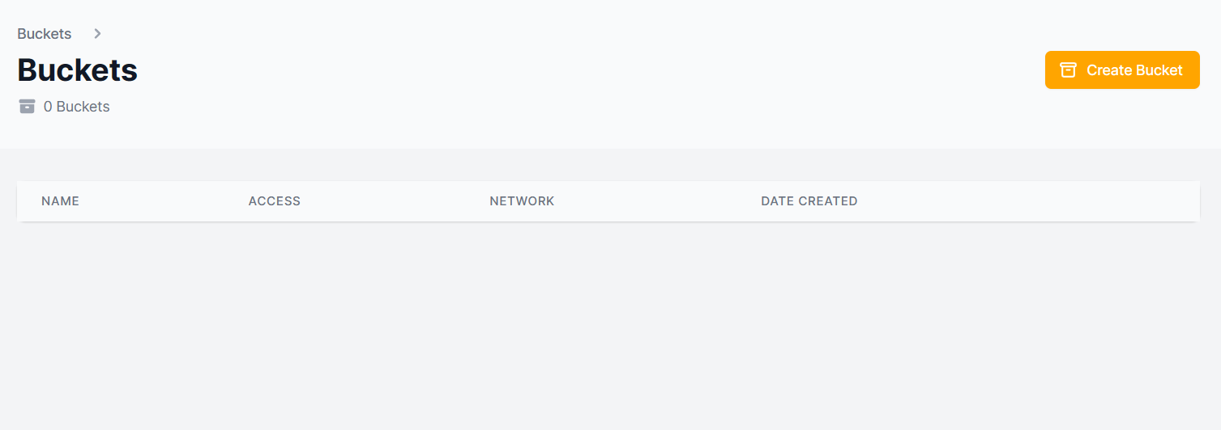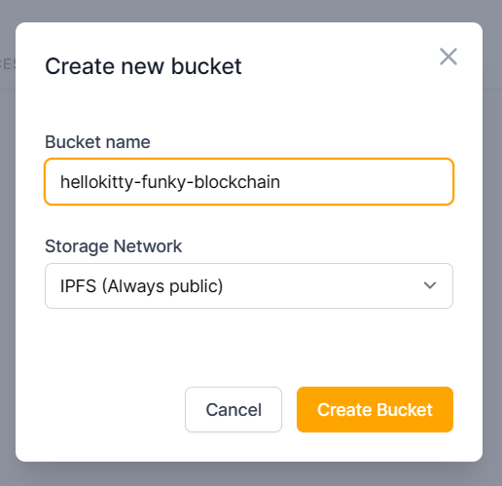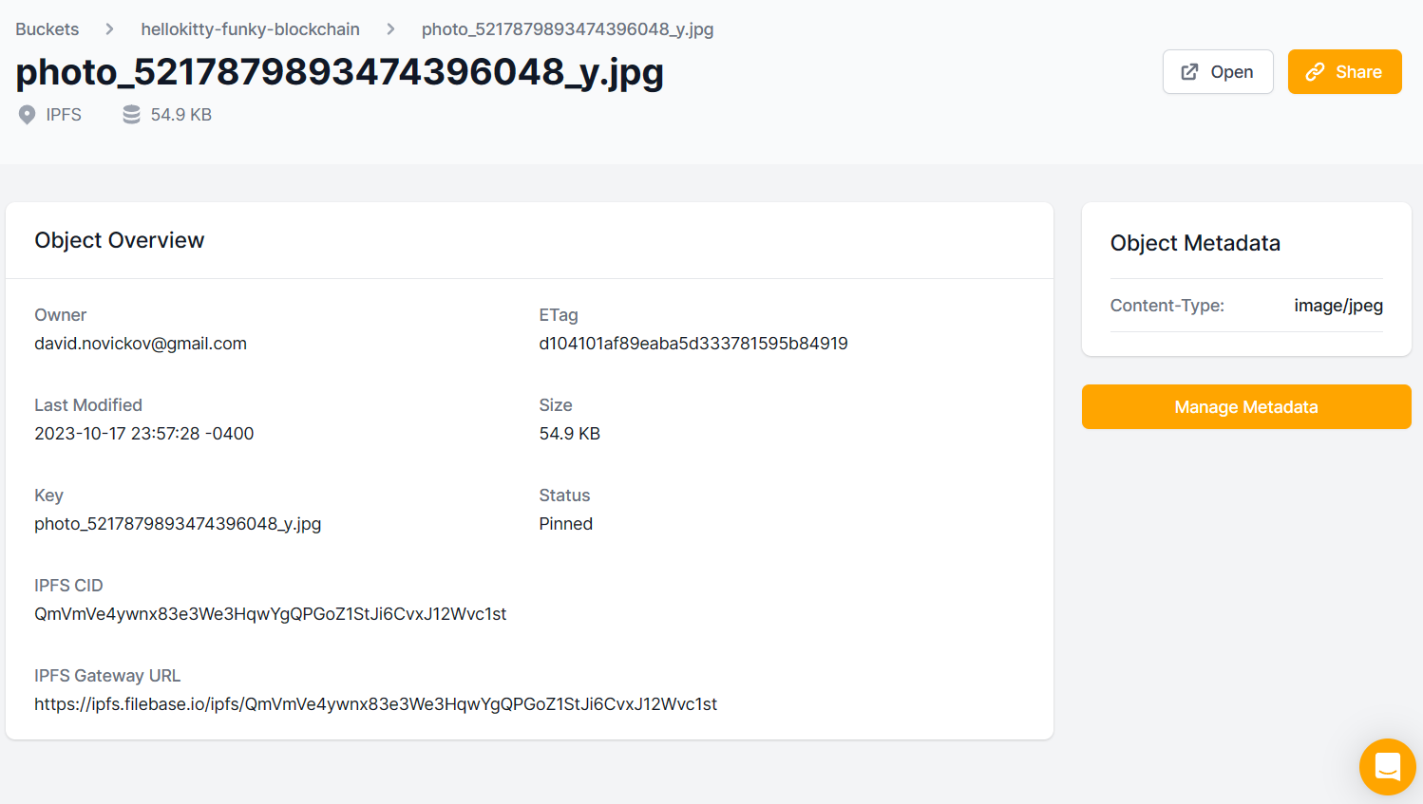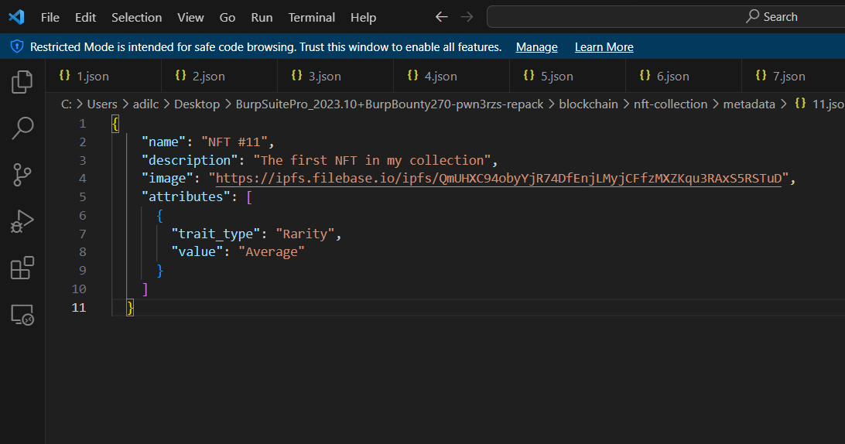

{

    "name": "NFT #11",

    "description": "The first NFT in my collection",

    "image": "https://ipfs.filebase.io/ipfs/QmUHXC94obyYjR74DfEnjLMyjCFfzMXZKqu3RAxS5RSTuD",

    "attributes": [

      {

        "trait_type": "Rarity",

        "value": "Average"

      }

    ]

  }

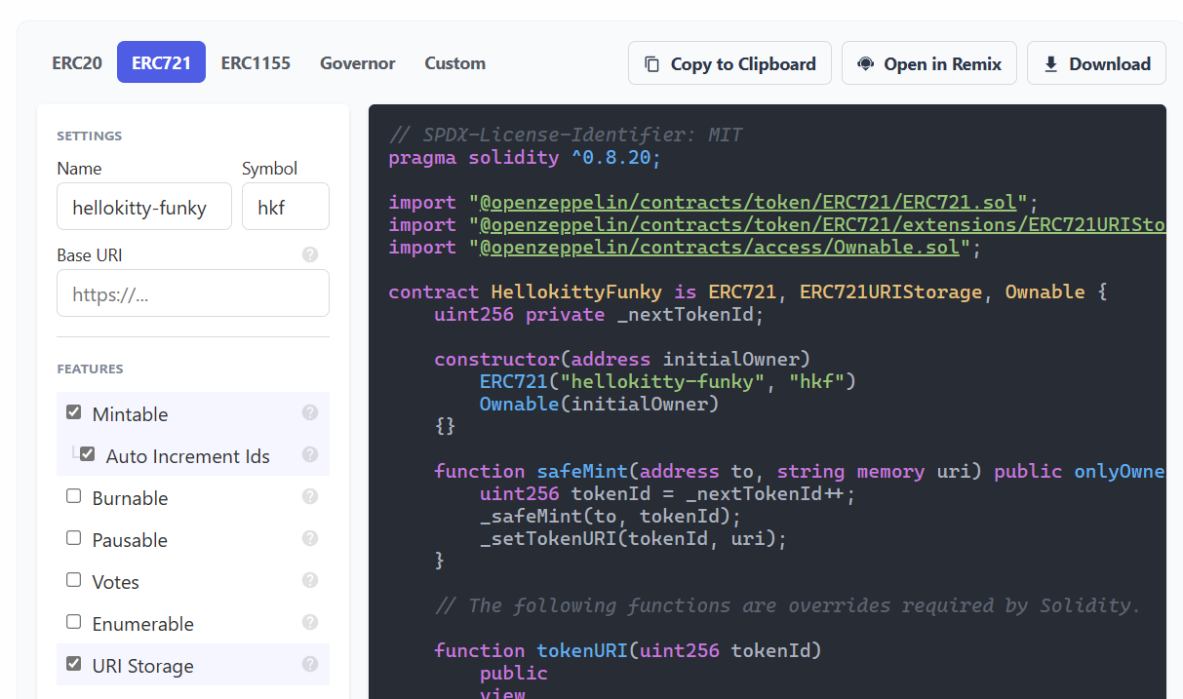

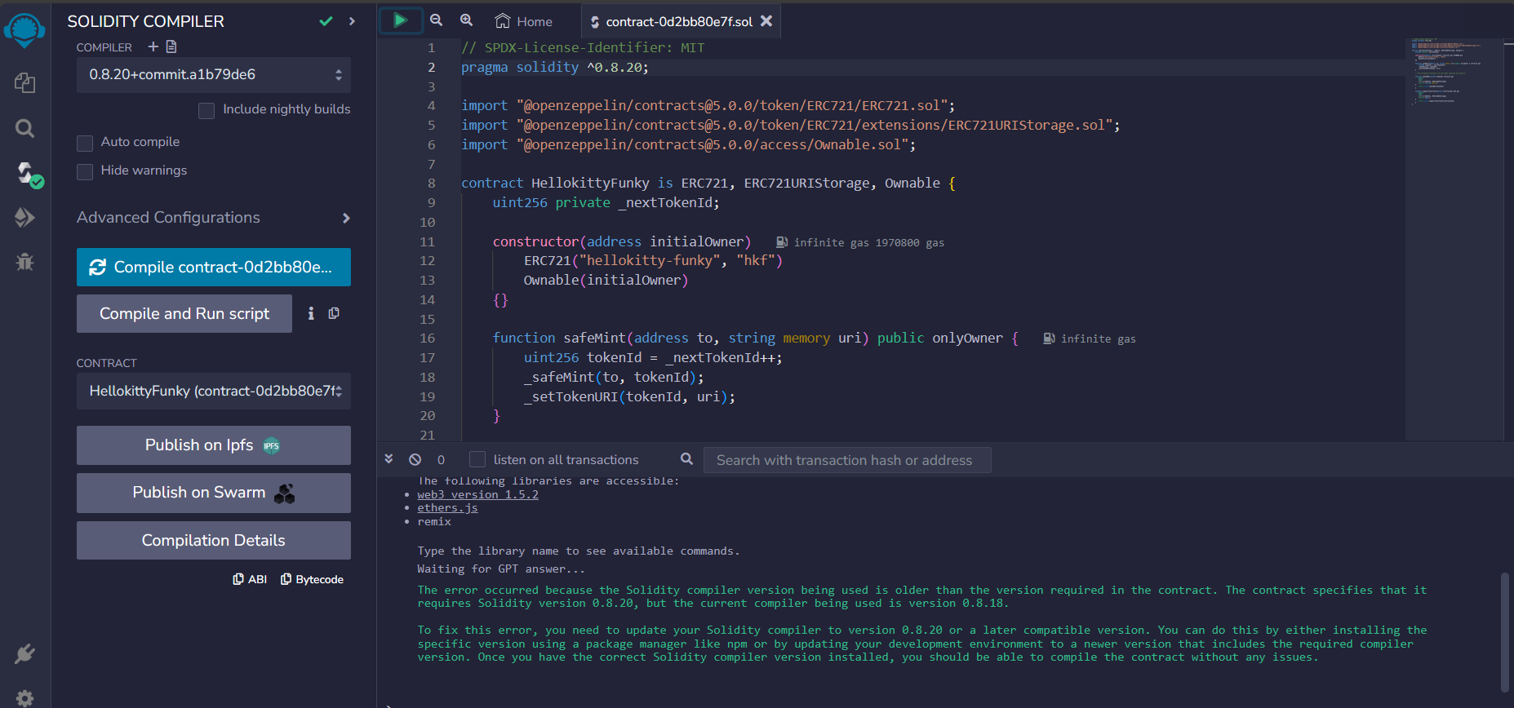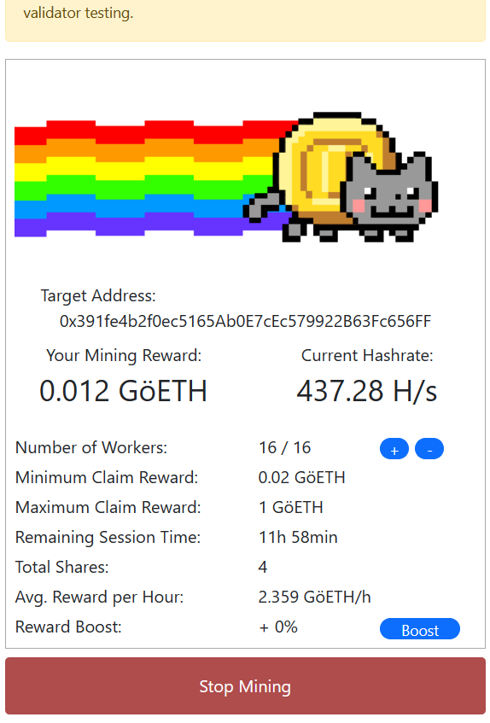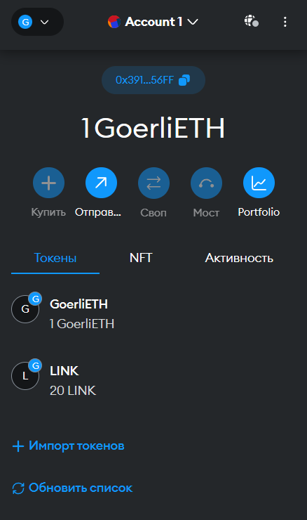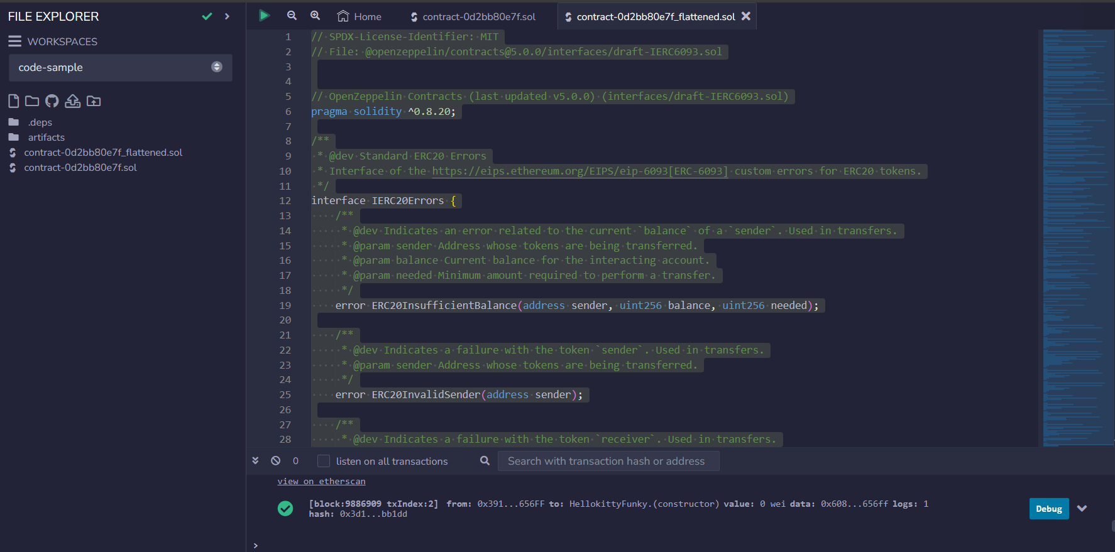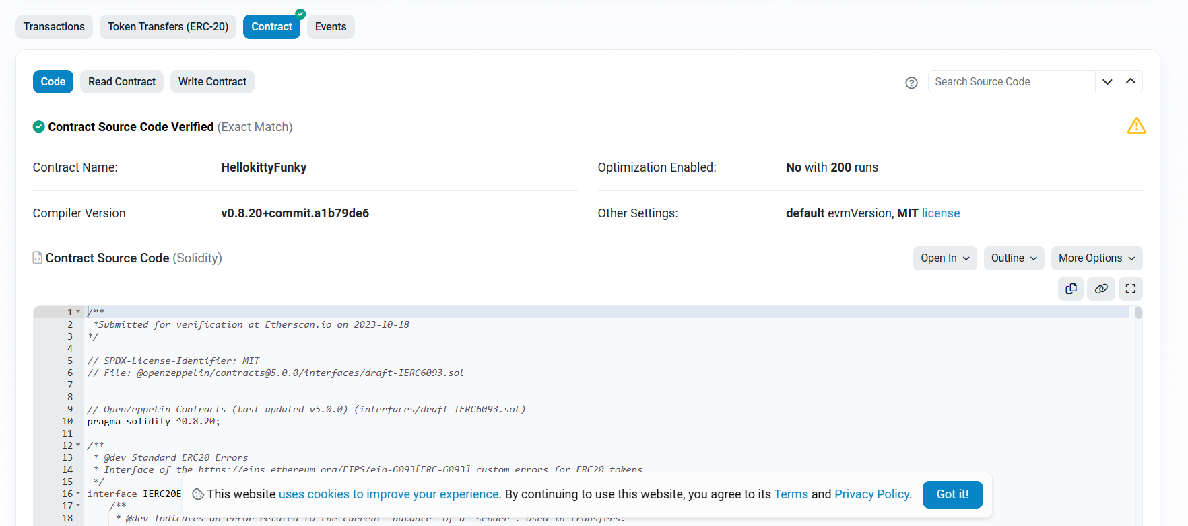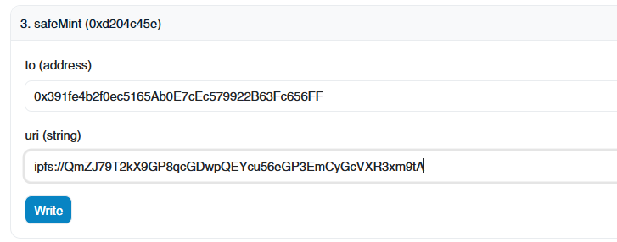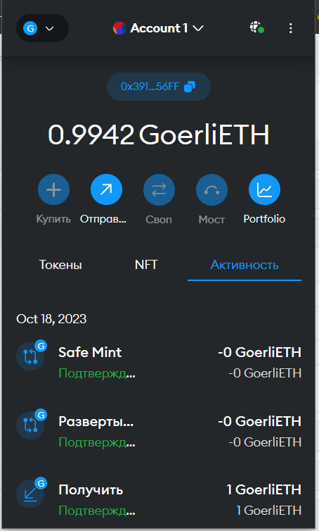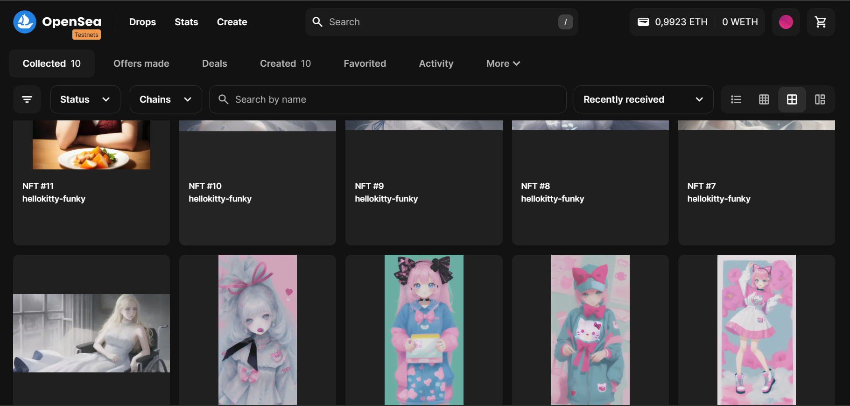

[NFT #1 - hellokitty-funky | OpenSea](https://testnets.opensea.io/assets/goerli/0xb40fe2bf2bf9874f6ec91ba3168d7fafddba3f89/0)

[NFT #2 - hellokitty-funky | OpenSea](https://testnets.opensea.io/assets/goerli/0xb40fe2bf2bf9874f6ec91ba3168d7fafddba3f89/1)

[NFT #3 - hellokitty-funky | OpenSea](https://testnets.opensea.io/assets/goerli/0xb40fe2bf2bf9874f6ec91ba3168d7fafddba3f89/2)

[NFT #4 - hellokitty-funky | OpenSea](https://testnets.opensea.io/assets/goerli/0xb40fe2bf2bf9874f6ec91ba3168d7fafddba3f89/3)

[NFT #5 - hellokitty-funky | OpenSea](https://testnets.opensea.io/assets/goerli/0xb40fe2bf2bf9874f6ec91ba3168d7fafddba3f89/4)

[NFT #6 - hellokitty-funky | OpenSea](https://testnets.opensea.io/assets/goerli/0xb40fe2bf2bf9874f6ec91ba3168d7fafddba3f89/5)

[NFT #7 - hellokitty-funky | OpenSea](https://testnets.opensea.io/assets/goerli/0xb40fe2bf2bf9874f6ec91ba3168d7fafddba3f89/6)

[NFT #8 - hellokitty-funky | OpenSea](https://testnets.opensea.io/assets/goerli/0xb40fe2bf2bf9874f6ec91ba3168d7fafddba3f89/7)

[NFT #9 - hellokitty-funky | OpenSea](https://testnets.opensea.io/assets/goerli/0xb40fe2bf2bf9874f6ec91ba3168d7fafddba3f89/8)

[NFT #10 - hellokitty-funky | OpenSea](https://testnets.opensea.io/assets/goerli/0xb40fe2bf2bf9874f6ec91ba3168d7fafddba3f89/9)

[NFT #11 - hellokitty-funky | OpenSea](https://testnets.opensea.io/assets/goerli/0xb40fe2bf2bf9874f6ec91ba3168d7fafddba3f89/10)